Method extension of CIPAC 32+33+345/TK/M
Determination of Piperonyl butoxide in polyethylene matrix by GC-FID
1. Sampling
The samples should be taken approximately according to the Manual on the Development and Use of FAO and WHO specifications for Pesticides shown in the diagram in Figure 1 at position 5. Sub sampling by 1 piece of size 30cm x 30 cm. Sample may be cut into 1-2 cm squares and thoroughly mixed.
Sample shall be separately packed in aluminium foil and kept out of direct sunlight at room temperature or lower.

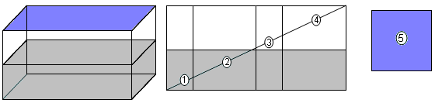

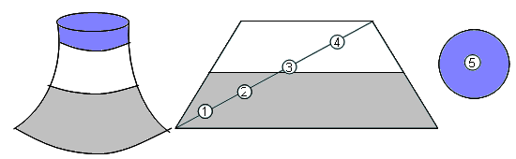

Figure 1. Sub sampling from a bed net as per the Manual on the Development and Use of FAO and WHO specifications for Pesticides

2. Identity test
GLC. As for piperonyl butoxide /32+33+345/TK/(M)2

3. Piperonyl butoxide. As for piperonyl butoxide /32+33+345/TK/(M)3, except: Calibration solution (REAGENTS), Preparation of sample and Determination (PROCEDURE)

OUTLINE OF METHODE. The sample is extracted by refluxing with xylene. The piperonyl butoxide content is determined by capillary gas chromatography using flame ionization detection and internal standard.

REAGENTS.
Piperonyl butoxide standard of known purity. Store below 0ºC
Octadecane internal standard
Xylene
Internal standard solution. Weigh (to the nearest 0.1mg) into a volumetric flask (50ml) octadecane (0.4 g). Fill to the mark with xylene and mix well.
Calibration solutions Allow piperonyl butoxide to equilibrate to ambient temperature. Then weigh (to the nearest 0.1 mg) into a volumetric flask (50ml) 0.25g. Fill to the mark with xylene and mix well. To pipette 0.50 ml, 1.50 ml, 2.00 ml, 3.00 ml and 4.00ml of this solution into 5 volumetric flasks ( 25 ml ). Add 2 ml of internal standard solution and fill up each to the mark with xylene and mix well.
Five solutions are used as calibration solutions A (C_{A}), B (C_{B}), C (C_{C}), D (C_{D}), E (C_{E}).
Transfer 200 µl out of each flask into separate GC vials. Place the vial into the sample tray of the GC apparatus
Description of the calibration solutions:
C_{A}: concentration of approximately 2.5 mg piperonyl butoxide in 25 ml xylene
C_{B}: concentration of approximately 7.5 mg piperonyl butoxide in 25 ml xylene
C_{C}: concentration of approximately 10.0 mg piperonyl butoxide in 25 ml xylene
C_{D}: concentration of approximately 15.0 mg piperonyl butoxide in 25 ml xylene
C_{E}: concentration of approximately 20.0 mg piperonyl butoxide in 25 ml xylene

APPARATUS. As for As for piperonyl butoxide /32+33+345/TK/(M)2
Gas chromatograph with flame ionization detection (e.g., Thermo Scientific Trace GC Ultra)
Capillary column fused silica (TR1), 30m x 0.32 mm (i.d.) with 100% methyl polysiloxane, cross-linked, surface bonded stationary phase and 0.25 µm film thickness
Electronic data evaluation system (e.g., Chrom-Card)
Usual laboratory equipment, e.g., electronic balance and laboratory glassware.

PROCEDURE
(a) Operating conditions (typical). As for piperonyl butoxide /32+33+345/TK/(M)3
(b) Preparation of sample. As for CIPAC 4568/M
Weigh (to the nearest 0.1 mg) 0.5 g of the sample put into a 250 ml reflux flask. Add 23ml xylene and 2 ml internal standard solution. Reflux the sample about 30 minutes. Cool down the sample to room temperature. Filter the solution through a 0.45 μm Teflon filter membrane. Transfer into a separate GC vial.
(c) System equilibration. As for piperonyl butoxide /32+33+345/TK/(M)3
(d) Determination. Inject in duplicate into the gas chromatograph 1µl portions of the calibration and sample solution in the following sequence:
C_{A}, C_{A}, C_{B}, C_{B}, C_{C}, C_{C}, C_{D}, C_{D}, C_{E} , S₁, S₁, S₂, S₂,… etc
(e) Calculation. As for piperonyl butoxide /32+33+345/TK/(M)3 and see test of linearity

$\text{Concentration}=R/w$ (g/kg)

R: Piperonyl butoxide reading from the analysis in mg.
w: mass of sample taken in g

